Master Document

South Metropolitan TAFE | RAD

Carl Haricombe, panashe madakasi & calvin moylan

Sprint 1, 2 & 3

2020

Contents

Sprint 1 1

1

Scrum Master Carl Haricombe 1

Business Rules in Software Development 2

Managed Services Quality Assurance 3

Quality Assurance: 3

Software Verification: 3

Software Validity: 3

Client Requirements 4

Project Plan 5

Development Plan 5

Notes: 7

Meeting 7

Analysis Documentation 9

Multi-platform 9

Backend Code 10

Test Documentation 10

Master Documentation 11

Meeting minutes 12

Source Control System 13

First edition 13

Final edition 14

Main 14

Responsive Multiplatform site 14

Master Document and Reports 14

Multiplatform Report 16

Testing plan 17

Requirements 17

Scope 17

Roles and Responsibilities 18

Test Methodology 19

RAD (Rapid application Development) 19

Testing strategy 19

Testing Environment 19

Hardware requirements 19

Test Cases 20

Sprint 2 27

Scrum Master Calvin Moylan 27

Project Plan 28

Development Plan 28

Notes: 30

Meeting 30

Software Review Plan 31

Performance Report 32

Backend Code 32

Test Documentation 33

Master Documentation 33

Presentation 34

Meetings 34

Source Control System 35

Example 35

Sprint Two Finished GitHub 35

Main 35

Responsive Multiplatform site 36

Master Document and Reports 36

Requirements 37

Roles and Responsibilities 37

Software Review Plan 38

Software Review 38

Performance 38

UI Design 39

Security 41

Client Requirements 42

Defect Tracking 43

Risks 43

Conclusion 44

Test Document 45

Introduction 45

Scope 45

Quality Objective 45

Roles and Responsibilities 45

Test Methodology 46

Testing strategy 46

Quality Assurance 46

Testing Environment 46

Hardware requirements 46

Test Cases 46

Sprint 3 56

Scrum Master Panashe Madakasi 56

Project Plan 57

Development plan 57

Source Control 64

Test plan 65

Introduction 65

Scope 65

Quality Objective 65

Roles and Responsibilities 65

Test Methodology 66

Testing strategy 66

Quality Assurance 66

Testing Environment 66

Hardware requirements 66

Test Cases 67

Optimisation Report 69

Handover 71

Carl Haricombe 71

WCAG 72

Review Report 74

How the team ensured the development quality of the software during the three sprints 74

What processes were utilised to ensure adequate control of the quality of the development process. 75

Describe the code testing process. 76

Software Verification: 76

Software Validity: 76

How can the software be supported for future modification and refinements (comments, code documentation, development plans). 77

Comments: 77

Code Documentation: 77

Development plans: 77

Provide a mapping of the user requirement to the final software product (did you meet the client’s expectations and requirements) 78

Source Control Snapshot 79

Project Plan 80

Notes 81

# 

# 

# Sprint 1

## Scrum Master Carl Haricombe

## Business Rules in Software Development

The business rule in software development refers to separating the coding end of the application into a logical stream where each person in the team is then assigned to an area in that stream. This will often come into effect when the client has a change of mind in what they want the application to do or look like.

Being given the RAD Agile methodology we had to follow the 6 steps to designing and developing the final prototype and having run through the Quality Assurance we decided as a team it would be best to undergo a grey box testing validation where Calvin Moylan handled the backend code to develop what the client required. Then Panashe Madakasi had to do the testing of the front to ensure that Calvin Moylan’s followed the requirements and met all the specifications to it (Panashe did have an understanding of the backend but when doing the testing was only required to test the front end which was able to tell us that the backend code Calvin Moylan’s used is working correctly). For validation we made use of dynamic validating method where we are able to monitor the working behavior of the software while executing the prototype.

In saying as Scrum master I was given the responsibility of dividing the team accordingly;

Carl Haricombe

1. Will be creating a project management plan that organizes everyone’s roles in a format that does not clash with one another but instead flows from one stage to the next.
2. I was also given the task to type up the analysis report where I underline everyone’s roles.
3. Finally I was given the task of designing the Master Document and add the necessary data of the first sprint to it.

Calvin Moylan

1. He was asked to make the necessary adjustments to the backend to ensure the Movie database website would be multi-platform.
2. He was in charge of creating a source control site for the team in which we could upload our completed or updated information where we would be able to double check one another’s work to keep a form of accuracy before bringing it forth to the client
3. He finally had to write the multiplatform report

Panashe Madakasi

1. Was in charge of developing the test documentation according to the QA standards of the Cite whilst ensuring that Calvin met the client’s requirements.

## Managed Services Quality Assurance

### Quality Assurance:

This is to ensure the quality set throughout a set of activities. It is used to both verify and validate the product, by verification it evaluates the documents, code and plans and requirements while validating it evaluates the product as a whole which is done through testing of every aspect that make the product.

In order to do the above the team has to abide by the quality standards example ISO 9001 and 90003.

### Software Verification:

This refers to checking and verifying the data and information in order to confirm credibility as well as the accuracy of the project. In this case we are checking the development stages and ensuring that we are following the requirements of the client.

There are normally 2 types of verifications

#### Static verification

This is where we inspect the code before execution, ensuring the requirements and specs are being met.

#### Dynamic verification

This focuses on the working behavior of the software and is done during the execution of the system.

### Software Validity:

This is when an actual test is performed on the project. This form of assurance ensures validating the critical aspects of the product. This is one of the most important aspects of the SDLC which in the end helps the team create the project at its peak performance.

There are 3 types of validation testing namely;

#### Black Box testing

This is where the internal design of the prototype that is being tested, isn’t directly known to the tester.

#### White Box testing

This method allows the tester to have complete transparency with the prototype.

#### Grey Box testing

This is more of a form of debugging; this testing is where the tester has a partial understanding of the design behind the prototype. Allowing the front-end testing to verify how the backend is working and running as expected.

### Client Requirements

The client had been given a test prototype of what they had first asked for however, they had then gone back and discussed that they wanted a Multi-platform website which had to be one of 2 types;

* Responsive
* Adaptive

Meaning that the website should be user friendly on different forms of devices like mobile devices, tablets as well as computer monitors.

There is an In-depth explanation on which of the 2 website formats we used and why. This was written up by Calvin Moylan as well as a well written up test document proving that we had met all the new requirements, this document was written up by Panashe Medakasi.

## Project Plan

Below is the project management plan which is where the Scrum Master of this week had divided everyone into doing their duties and what days they are expected to be worked on and completed so that tasks do not overlap one another. This was necessary to ensure we stick to due dates, in this case Sprint 1 had to be completed by the 11 of November 2020 because the 12 of November 2020 was the due date for the first presentation with the client to demonstrate our progress and that we had managed to complete and display what ACME Entertainment Ltd had required us to do.

## Development Plan

In this plan we had to compare our updated site with the expectations and requirements of the client. The methods we used to go about this were pretty simple, when each team member completed their end of the assignment we would upload it to Github and notify the others to check that all the needs of the client had been for example the client wanted a multiplatform website and so we went on a venture to find the best and quickest solution which we believed to have been a responsive website.

We also ensured that we were following the QA cite ISO 9001 and 90003 with regards to the verification and validation of the website we made use of dynamic validating method where we are able to monitor the working behavior of the software while executing the prototype. And for verification we made use a blackbox method because the client did not know much about backend coding we wanted to display to them that we tested it through the front end to assure them that the backend is working accordingly to their requirements

|  |  |  |  |
| --- | --- | --- | --- |
| Task | Who Completed it | Who checked it | Was it good |
| Analysis Document | Carl haricombe | Panashe | Ensured he added all necessary information from Business rule, to quality assurance and the project plan and gnatt chart as well as stating the requirements by the client |
| Multiplatform Document | Calvin Moylan | Carl Haricombe | Ensured that he mentioned all details having to do with the fact that we chose a responsive site and why we decided on it and how we went about it |
| Backend Code | Calvin Moylan | Panashe Madakasi | Ensured that code was correct and performed the task required by the client and that the necessary commenting was added |
| Test Document | Panashe Madakasi | Carl Haricombe | Checked that it was tested with different web browsers and on different size devices ranging between Monitors, tablets and mobile devices |
| Master Document | Carl Haricombe | Panshe Madakasi | Ensured that all sub documents were added and correct formatting was used and constant throughout the entire document |
| Source Code System | Calvin Moylan and Carl Haricombe | Calvin Moylan and Carl Haricombe | Ensured that all code and reports were completed and inserted in and uynderstanable format under Sprint One folder |

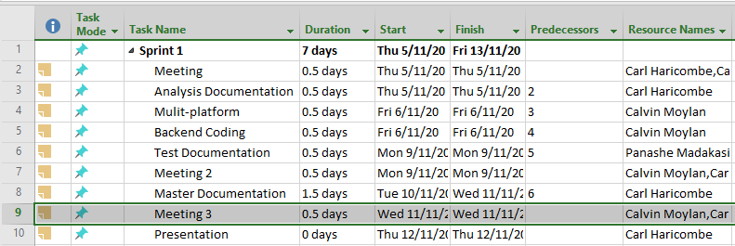

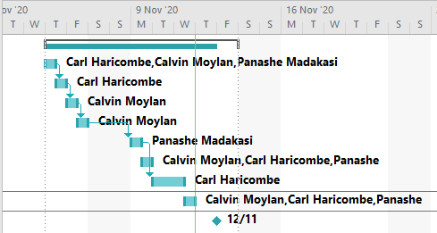

## Notes:

### Meeting

#### Meeting 1

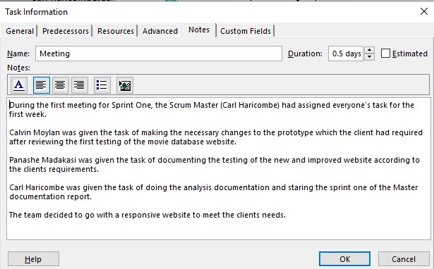

#### Meeting 2

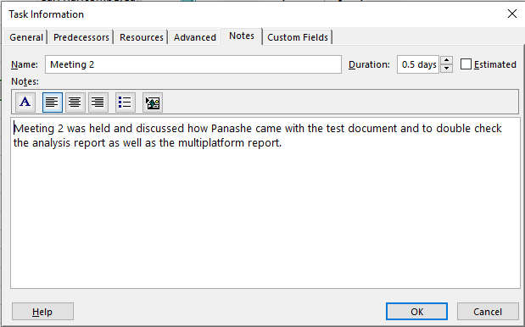

#### Meeting 3

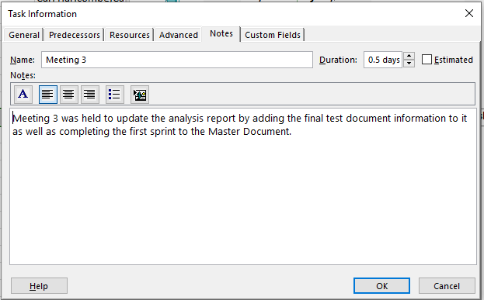

### Analysis Documentation

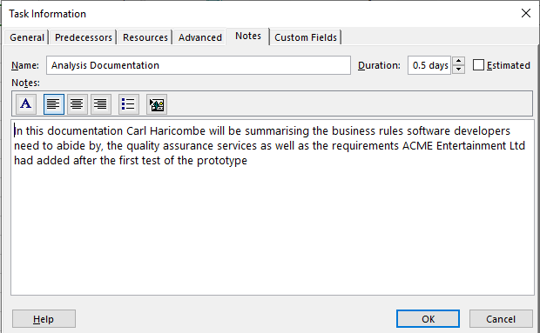

### Multi-platform

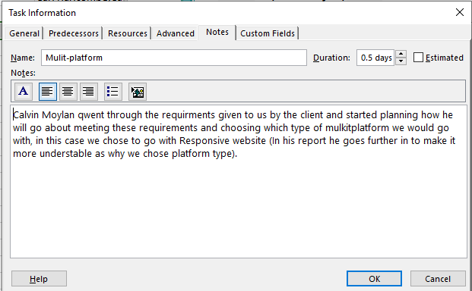

### Backend Code

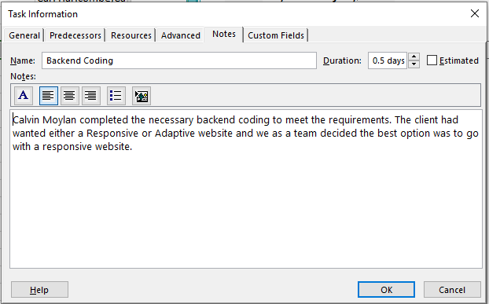

### Test Documentation

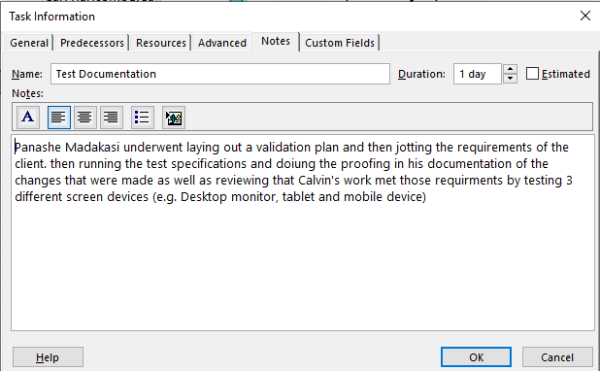

### Master Documentation

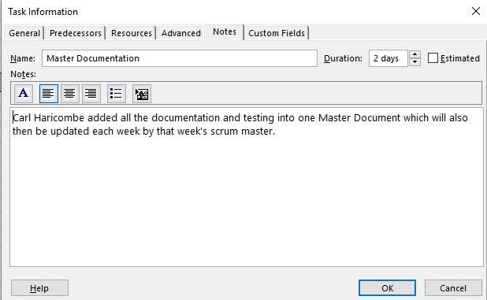

#### Presentation

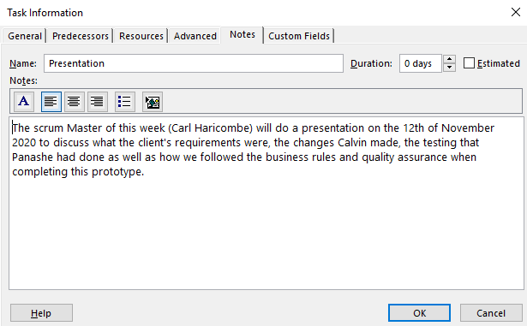

### Meeting minutes

#### Meeting 2 (Monday 9/11/2020)

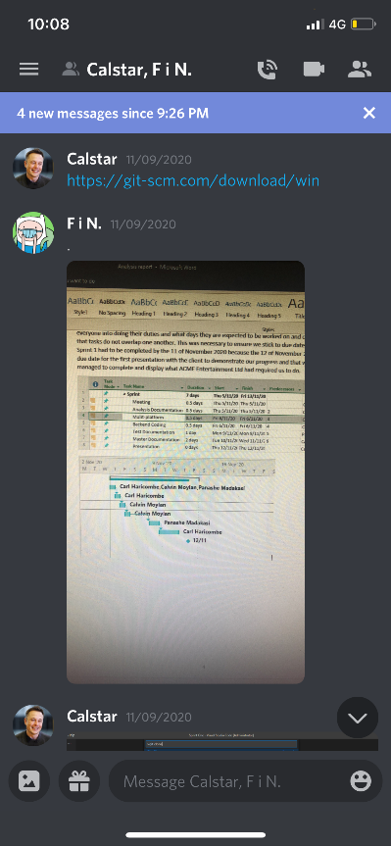

#### Meeting 3 (Wednesday 11/11/2020)

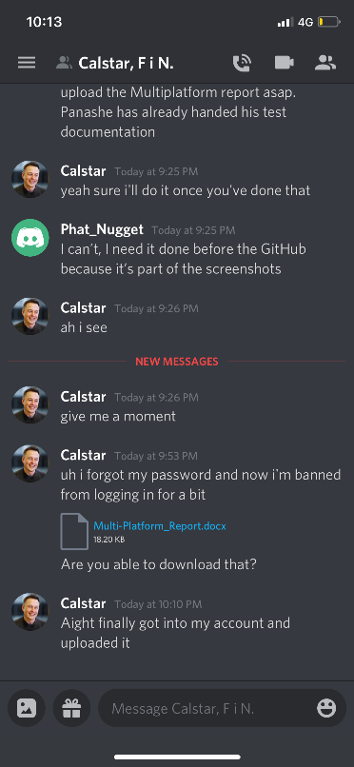

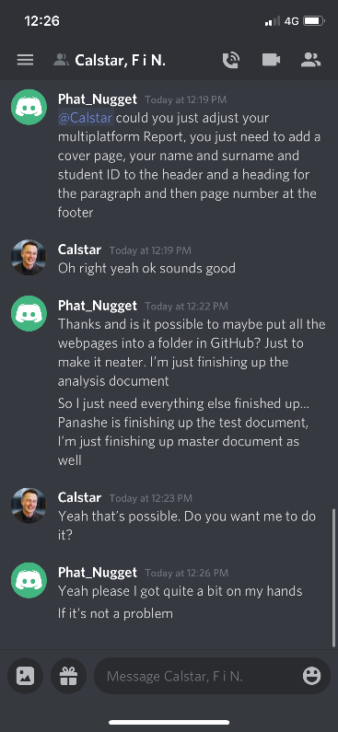

## Source Control System

This refers to the system used to track our changes and progress. Calvin Moylan had created a group project folder and made myself and Panashe Madakasi contributors. This way we were able to keep everyone updated on our progress but also to check that we are doing our part and following through with additional advice or extra data we may feel the other is missing.

### First edition

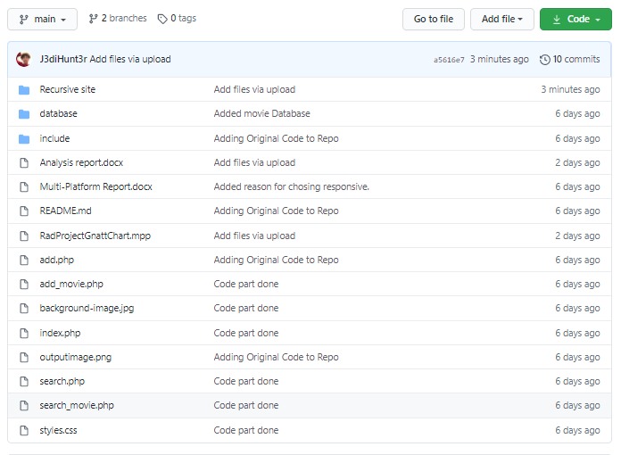

Adjust were made as you can see the above folder was cluttered with the updated php files. I then moved them into a folder called “Responsive Multiplatform site” (this site is the updated version of the original site, containing the new code required by the client). The test document was also not added at that time.

### Final edition

### Main

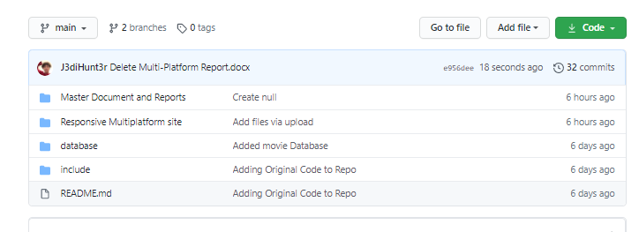

### Responsive Multiplatform site

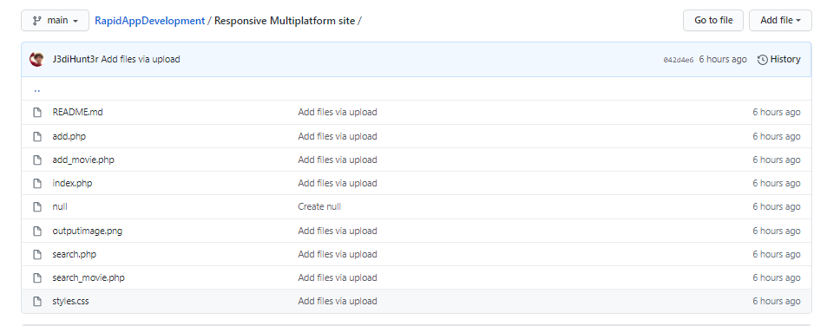

### Master Document and Reports

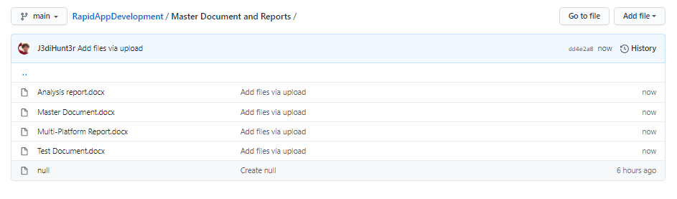

## Multiplatform Report

To make sure the website met the criteria of being capable of supporting multiple platform, I chose to go with the responsive design. This means all website elements stay in the same position and are resized to make sure they fit on all devices. I chose this over adaptive design as the website was almost already in a state where it could easily be converted to responsive design thanks to the simplistic design of the prototype. The website meets this requirement as it is now able to resize the element to fit on screen. This is in contrast to the prototype which didn’t have support for responsive or adaptive design which lead to element clipping out of bounds of the screen when shrunk.

I went about making the website responsive design by setting each main element a max width and setting their width to auto. This made it so they only need to be as big as need and also makes sure that each element was no too big for the screen. The biggest problem was the search table which would constantly clip once shrunk. I fixed this by making the words inside the cells wrap text which allowed the table to be shrunk even further to allow viewing on a smaller device.

## Testing plan

### Requirements

Acme Entertainment has requested for a prototype data base that can be used across all major digital platforms, Acme Entertainment has also requested for the prototype to use an adaptive or responsive design approach, with the diversity of devices with varying display sizes having the UI scale properly with all devices is important.

### Scope

#### Features (Movie Database website) In Scope

* Ability to search through the database for movies
* Ability to Find top ten more searched movies
* Ability have a website using one of the two design options; Adaptive or responsive

#### Functional

* Search for Movies
* Responsive website (scaling)
* Top ten searched movies

#### Non- functional requirements

* User interface
* Software interface
* Database

#### Quality Objective

* Bugs and any issues fixed before being demonstration
* All features apparent
* Responsive website

### Roles and Responsibilities

Carl Haricombe (Scrum Master)

* Project management plan (sprint one)
* Analysis Report
* Demonstration
* Source control
* Updated the Source Control (Github)

Calvin Moylan

* Coding (Developer)
* Multi-Platform Report (adaptive v responsive)
* Created Source control (Github)

Panashe Madakasi

* Software Development Testing Plan

### Test Methodology

## RAD (Rapid application Development)

* Using Rapid application Development allowed our team to quickly create a website that connects to a movie database and as a search function, by using a prototype already created and tailoring it to the client’s needs of having the website being responsive or adaptive significantly reduces the development time and allows for a fast delivery.

### Testing strategy

For testing this we will be using a behavioral testing strategy, this focuses on functions, workflow and performance of the prototype. Behavioral testing can also be classified as black box tested where the testing is done through the perspective of the ender user. The testing covers multiple functions that the user would encounter, using black boxes testing would be the closest to how the user would be using the website and would also assure us that the code is working as intended.

#### Quality Assurance

* Quality assurance will up to the Cites management standards evaluation project performance and the hand off complies with customer requirements.

### Testing Environment

|  |  |
| --- | --- |
| **OS** | **Browser** |
| Windows 10 | Chrome |
| Windows 10 | Microsoft edge |
| Windows 10 | Internet explorer |
| Mac OS | Chrome |
| Mac OS | Safari |
| Simulated iPhone (5/se) | Chrome |
| Simulated iPhone (6/7/8)+ | Chrome |
| Simulated iPhone (X) | Chrome |
| Simulated iPad and IPad (Pro) | Chrome |
| Simulated Galaxy Note 2 | Chrome |

The use of google Chrome’s developer tools and mainly the use of the Device tool bar will allow us to simulate having the prototype running on mobile devices without having to run the prototype on the device. The Device tool bar displays the screen size of the selected device and only allows the developer to use the website as if it was being used on that device.

### Hardware requirements

* Windows 10 (Computer)
* iMac or Mac book (Computer
* Internet connection (Wifi or Ethernet connection, modem)
* Peripherals (mouse and keyboard)
* Monitor

### Test Cases

|  |  |
| --- | --- |
| Prototye | Prototype with clients Requirements |
| Google Chrome | Google Chrome |
|  |  |
| Microsft edge | Microsoft egde |
|  |  |
| Microsoft Edge (Resized) | Microsoft Edge (Resized) |
|  |  |
| Internet explorer | Internet explorer |
|  |  |
| Internet explorer (Resized) | Internet explorer (Resized) |
|  |  |
| Simulated iPhone (5/se) | Simulated iPhone (5/se) |
|  |  |
| Simulated iPhone (6/7/8)+ | Simulated iPhone (6/7/8)+ |
|  |  |
| Simulated iPhone (X) | Simulated iPhone (X) |
|  |  |
| Simulated iPad and IPad (Pro) | Simulated iPad and IPad (Pro) |
|  |  |
| Simulated IPad (side view) | Simulated IPad (side view) |
|  |  |
| Simulated Galaxy Note 2 | Simulated Galaxy Note 2 |
|  |  |

# Sprint 2

## Scrum Master Calvin Moylan

## Project Plan

Sprint Two of the Rapid App Development started on the 12th of November 2020 and will continue through the week until the 19th of November where the scrum master, Calvin, will present the completed tasks to the client which had been set by ACME Entertainment Ltd. Each member of the team was assigned to task which they had to complete before the deadline.

## Development Plan

For this week, we are to continue on what we have developed thus far, continuing from making the website support multiple platforms, setting up our working repository and completing report documents. We have separated last week’s code and reports from this weeks by making a new folder within the GitHub repository. The client has requested we have a membership signup page which will allow users of the site to sign up and receive newsletter emails from the website. They also requested that we have an Admin page which will be used to send newsletters and delete members from the database. For this plan to be successful, the website must meet the client’s requirements and expectations.

To ensure that we meet the expectations of the client, we followed QA cite ISO 9001 and 90003 to verify and validate the website’s functionality through a dynamic validating method and through the use of the black-box method as this client does not have the knowledge to understand what the code is doing behind the scenes. This is the best way to show that the code is working to someone who does not program themselves since if it all functions correctly, the code must be working.

|  |  |  |  |
| --- | --- | --- | --- |
| Task | Who Completed it | Who checked it | Was it good |
| Software Review Plan | Calvin Moylan | Panashe Madakasi | The Software Review Plan meets the requirements and is all good for submission to the client. All relevant information has been included. |
| Performance Report | Calvin Moylan and Panashe Madakasi | Carl Haricombe | The performance report has been correctly conducted and included the information relating the website’s performance. |
| New Feature set Code | Panashe Madakasi | Carl Haricombe | The code for the features has been completed and meets the client’s requirements for this week’s sprint. |
| Test Document | Carl Haricombe | Panashe Madakasi | The test document has been completed which shows the new feature set all working correctly and as intended. Adding users to database works, sending emails works and deleting users from database works. |
| Master Document | Calvin Moylan | Carl Haricombe | The master document has been updated with all the information relating to this week’s sprint. There has been 3 new documents added to the master document this sprint. |
| Source Control System | Calvin Moylan and Carl Haricombe | Calvin Moylan and Carl Haricombe | The source control system has been updated to reflect this week’s progress and completion. |

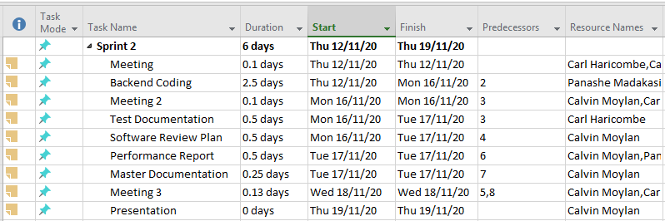

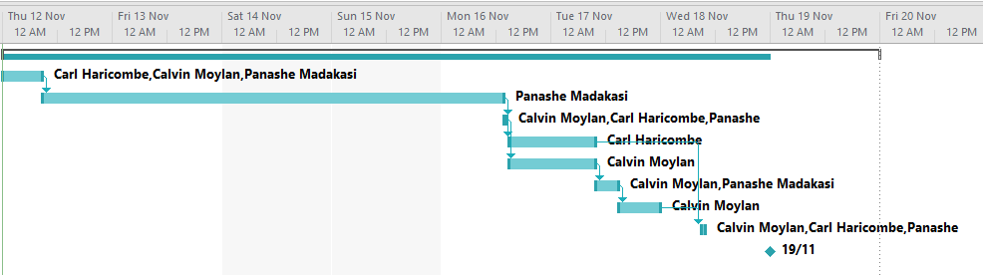

## Notes:

### Meeting

#### Meeting 1

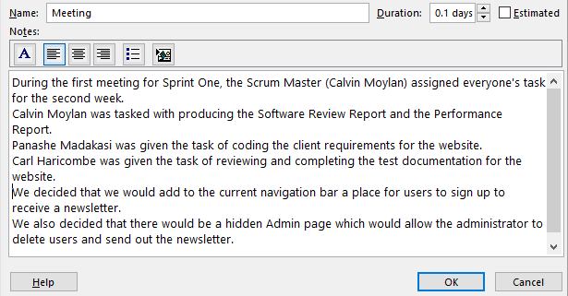

#### Meeting 2

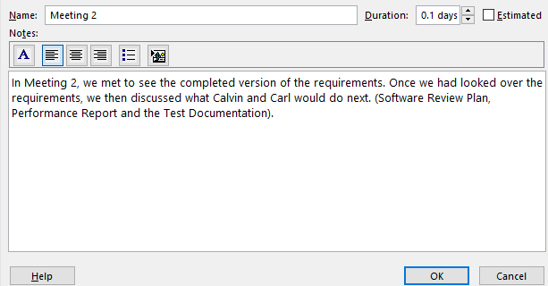

#### Meeting 3

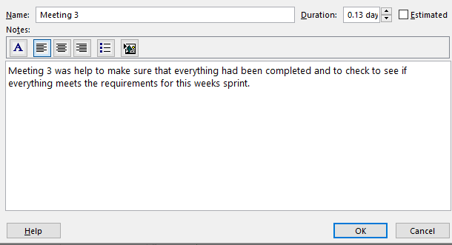

### Software Review Plan

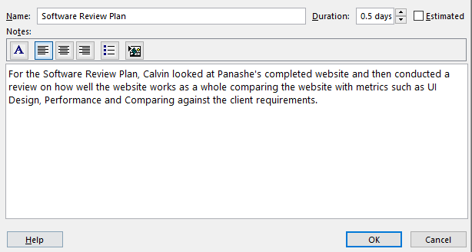

### Performance Report

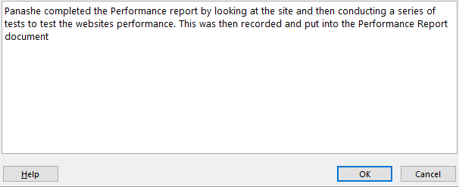

### Backend Code

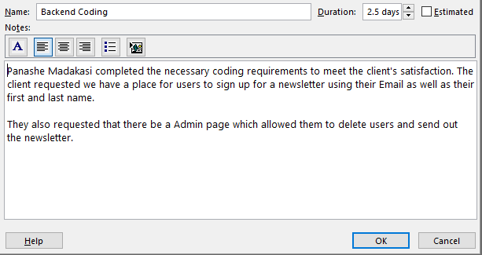

### Test Documentation

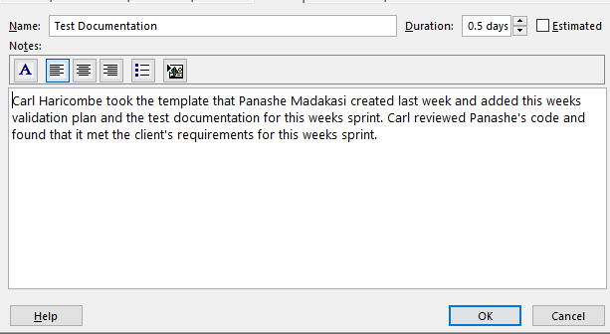

### Master Documentation

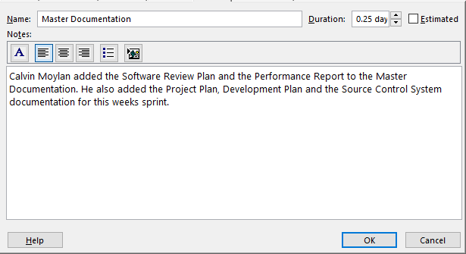

### Presentation

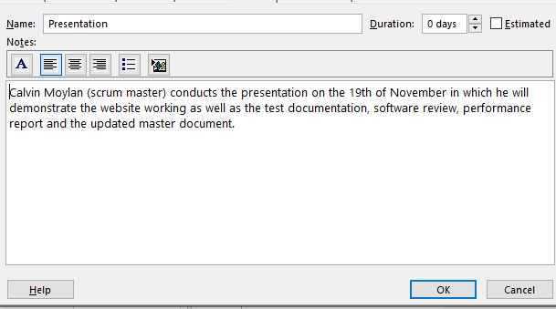

### Meetings

#### Meeting 2 (Monday 18/11/2020)

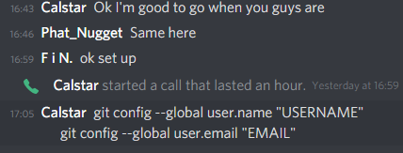

## Source Control System

In sprint two we are continuing using our existing GitHub repository from last week’s sprint. To separate each weeks work we have created different folders for each week example is shown below. We are continuing to use this repository as it already has our existing website and documentation on it. The source control system helps us to make sure we are always editing the latest version of the repository and makes sure that we always have a backup of our old changes.  
  
The repository this week was managed by Calvin with Carl uploading his documents to the repo and Panache uploading the completed version of the website.

### Example

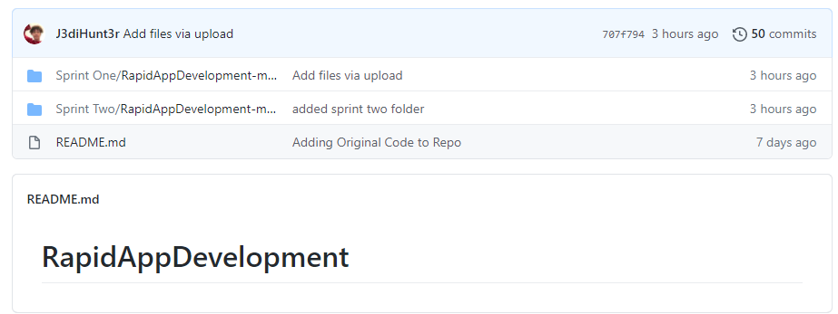

This shows that that we have split off from Sprint One and have moved onto working in Sprint Two where we will complete the client’s requirements for this week’s sprint.

### Sprint Two Finished GitHub

### Main

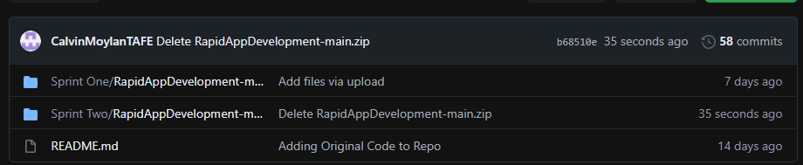

### Responsive Multiplatform site

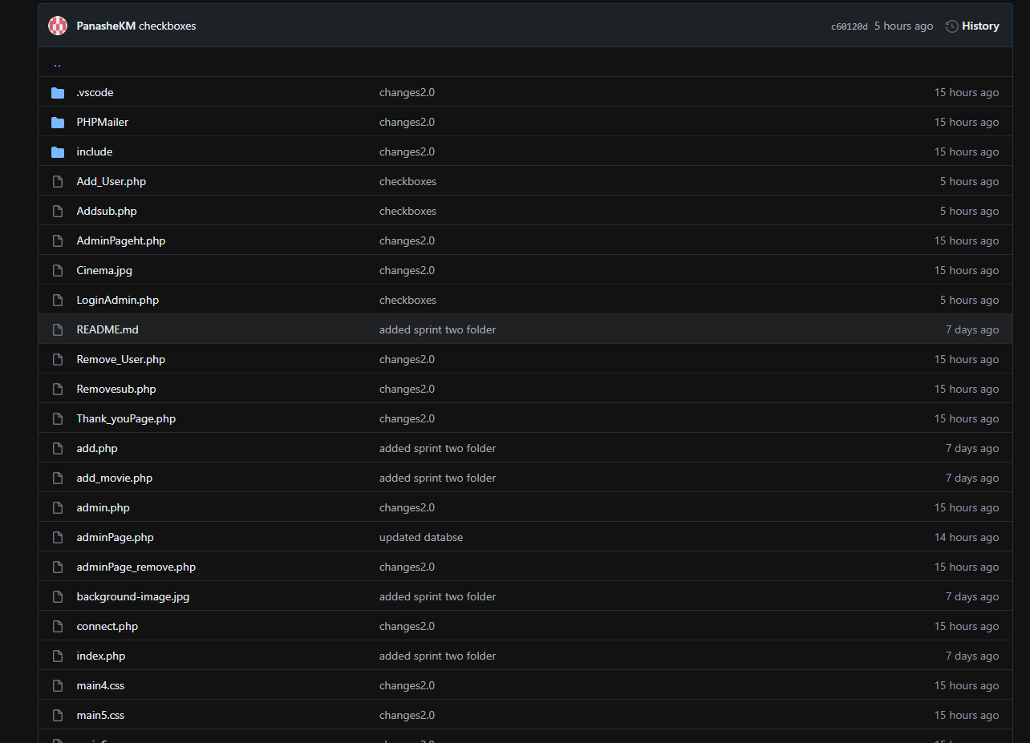

### Master Document and Reports

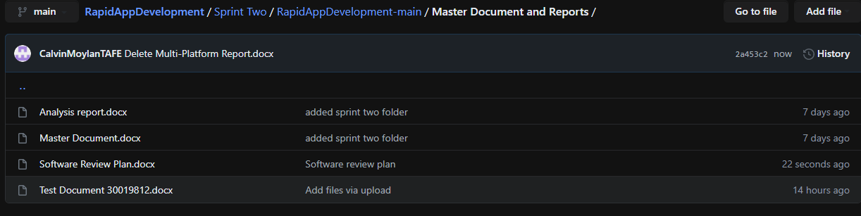

## Requirements

AMCE Entertainment has asked us to add new features to the website for sprint two of the Rapid App Development. The requirements are to include a membership sign up page which will allow for users to enter their full name and email to receive newsletters from the website. They will have the option of subscribing to this newsletter. They also asked us to provide an Admin page where they will be able to view all members of the database, delete members from the database as well as send out the newsletter.

## Roles and Responsibilities

Calvin Moylan (Scrum Master)

* Project management plan (sprint two)
* Software Review Plan
* Demonstration
* Source control
* Updated the Source Control (Github)

Panashe Madakasi

* Coding (Developer)
* Performance Report
* Updated the Source Control (Github)

Carl Haricombe

* Software Development Testing Plan

## Software Review Plan

A plan for reviewing this week’s software product must be conducted to ensure the requirements of the client has been met and to ensure that they will be satisfied with the end product. Below is outlined what the new website feature set will compared against. These must be in line with the CITE Managed Services QA.

I will make sure that the requirements of the product has been met by performing a review of the finished software by comparing it against the performance of the website, the UI design, security and the feature requirements set by the client.

### Software Review

### Performance

The performance of the website must be quick. Users will not want to spend their time waiting for a webpage to load. Luckily for us, this website does not use any hardware intensity code just as JavaScript so all the user’s web browser has to do is render the HTML sent by the server. The user sign up and admin portal all happen on the server side so the user does not have to worry about having to wait long periods of time for their browser to handle it. Having the server handle all sensitive requests is also makes the website secure.

The website was originally written by Calvin which was then improved upon by Panashe during the second week of sprints.

Here is a list of performance stats:  
Index Page: 0.0002 seconds  
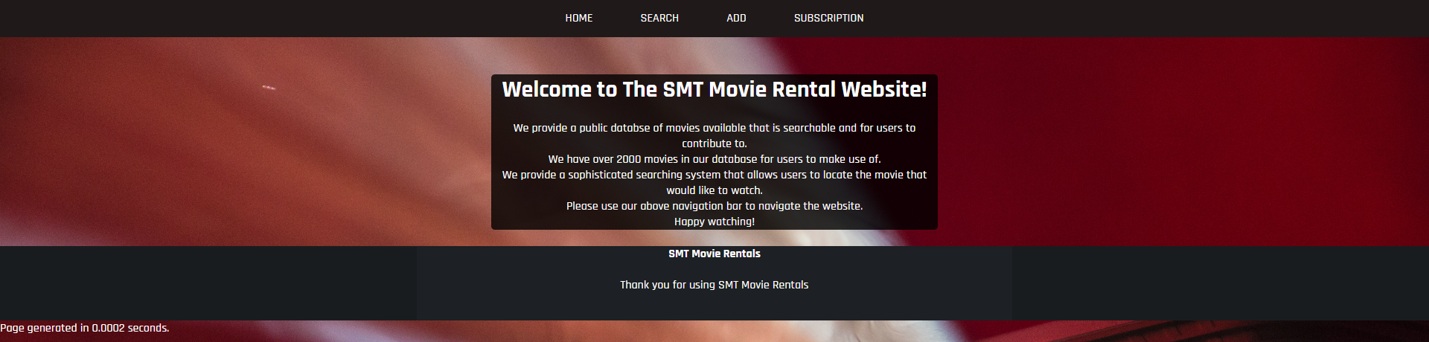

Searching for all movies: 0.0432 seconds  
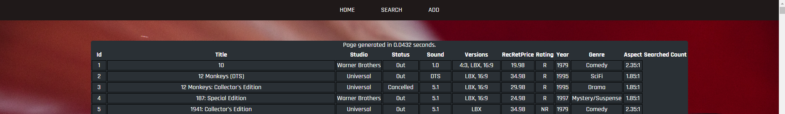

Admin Page: 0.0359 seconds  
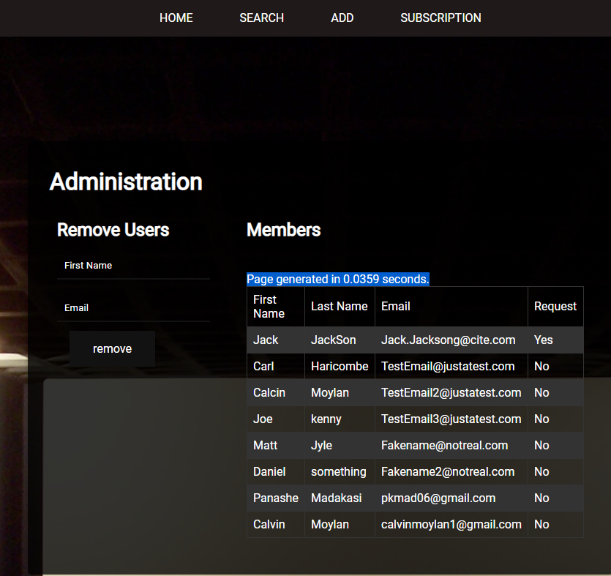

### UI Design

The UI Design must be simplistic and easy to navigate. We went about this by having one ribbon navigation bar across the top of the screen which has all pages that is accessible to the users of the website. The UI must also be cross platform compatible which was completed last week during sprint one but also must be applied to this week’s sprint.  
Index:  


Search:  
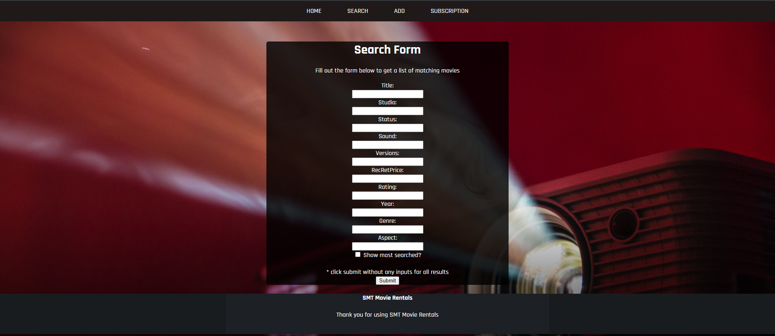

Add:  
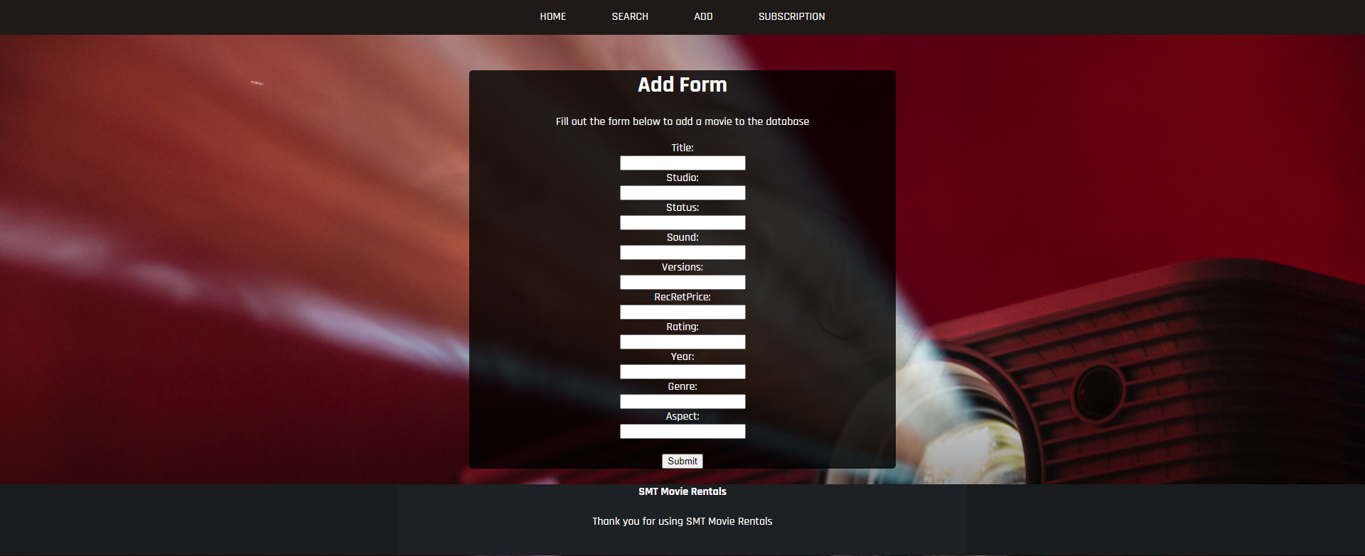

Subscription:  
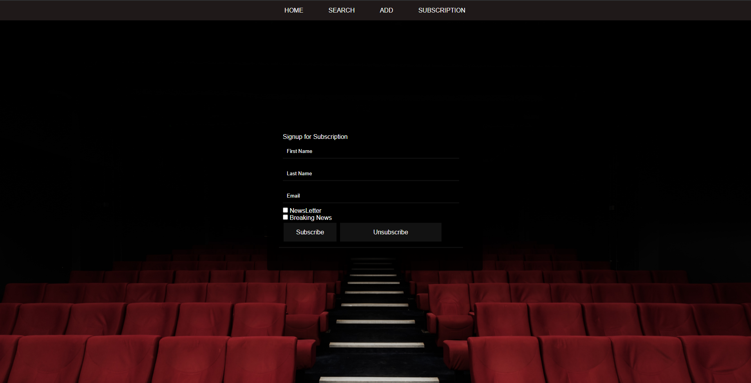

The UI Design is simple and is consistent across the entire website.

### Security

The website must be secure. If the website is not secure this could lead to devastating effects for the end user which may include having their personal email leaked to the public.  
To ensure that the website is secure, I used CITE’s quality control to identify problematic bits of code and to sniff out any problems with the website’s code. I figured the areas that would be prone to security faults would be the user inputs. E.g. name entering. These inputs must be filtered and sanitised before being entered into the database.  
Another security hole may be the SQL connection. We have chosen to use PDO, this is because it is more secure than MySQLi.

We have completed a test case document and code review to ensure that the website is as secure as possible.

We also used a PHPSniffer to detect any errors:  
<https://phpstan.org/>

Admin page:  
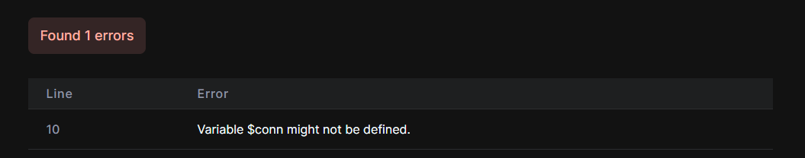

Adding Member:  
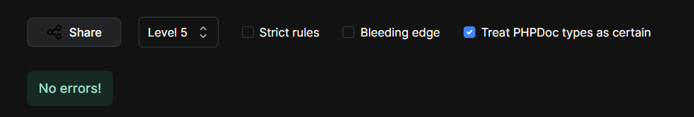

Admin Login:  
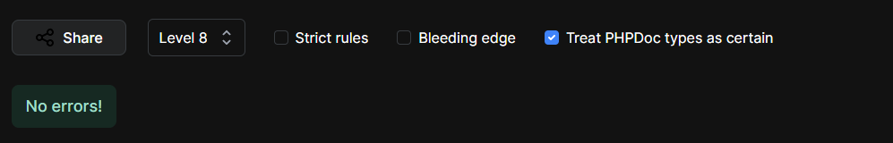

We reviewed these and made changes accordingly.

### Client Requirements

The website meets the client’s requirements.  
The requirements were that we must include a membership signup page with an option to sign up to newsletters. See below:   
We were also required to include an Admin page. See below:   
The admin page also required functionality to see all members and to delete them. See below:   
Finally, the website must also be able to send newsletters out to the members who have subscribed to them. See below:

Admin Page:  
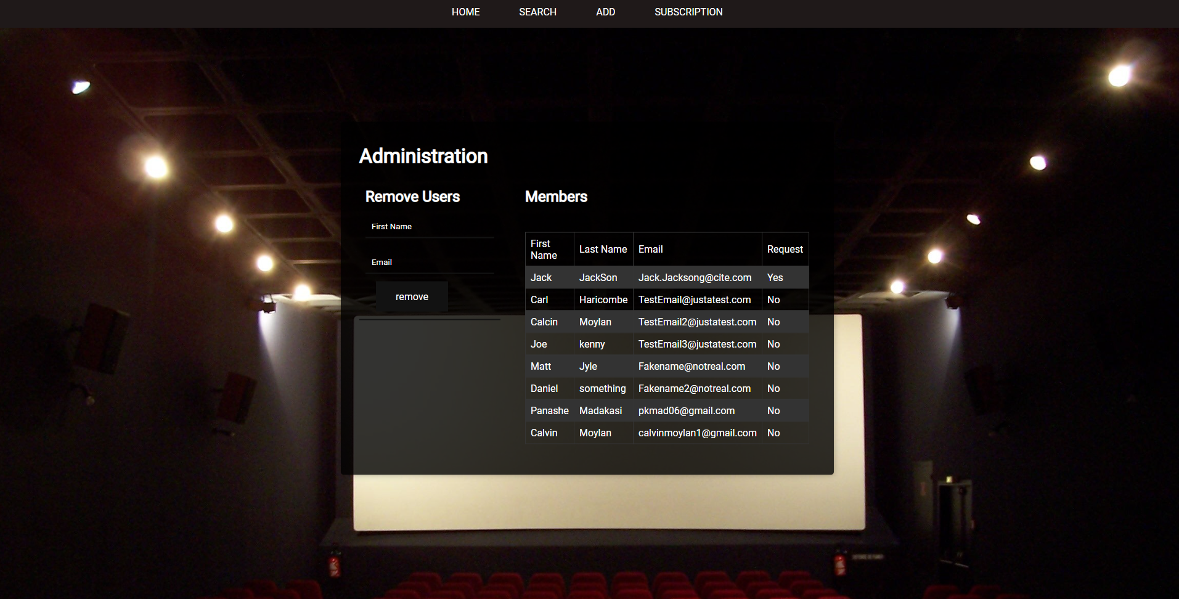

Sign Up Page:  
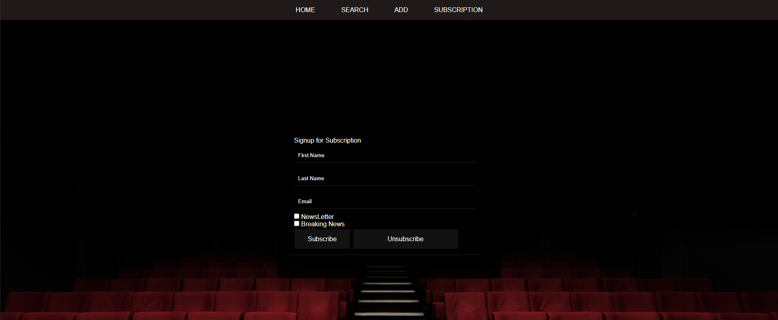

Admin Login page:  
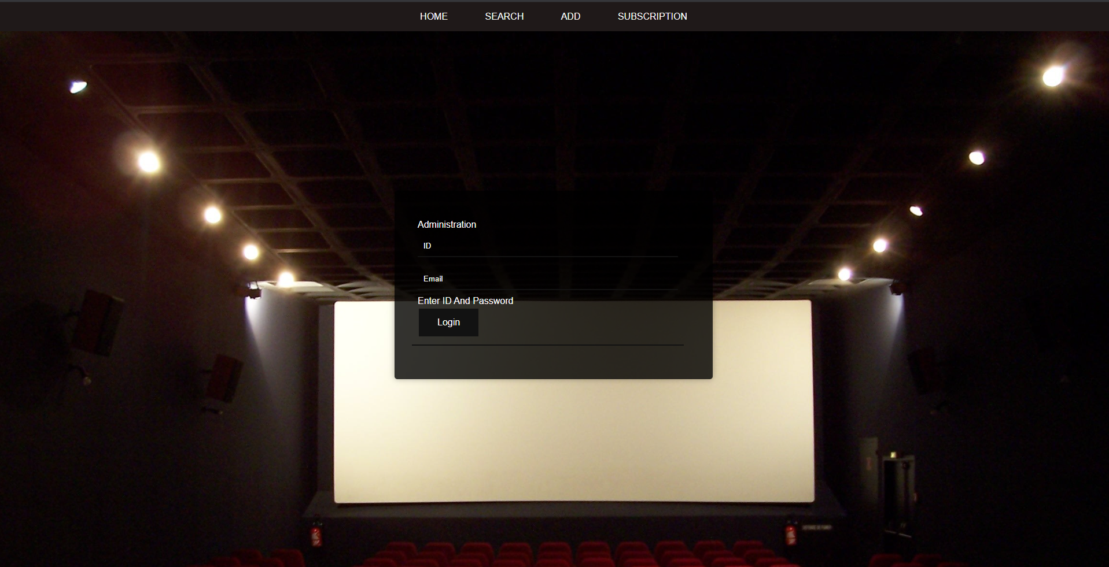

### Defect Tracking

There exists no defect tracking on the current version of the website. This means that we will have no way to see if there are any errors with the website and why it might be erroring. It may be useful to investigate adding some sort of defect tracker in the future.

## Risks

After conducting a review of the final product, I can conclude that the website is not prone to any sort of security risks. This is because all inputs from the user has been sanitised and all sensitive information is stored away from the users behind a database.

## Conclusion

Based on these findings, I can assure the client that the software written by Panashe for sprint two of the Rapid App Development meets all set requirements and it will meet the client’s satisfaction since the website has good performance, has simple and repetitive UI Design, Secure and the Client’s requirements has been met.

## Test Document

### Introduction

Our client Acme Entertainment has requested a User and Admin login and subscribe section to the website which are both linked to a database each, also a section to the site needs to allow an Admin member to remove a User from the site as well as a validation filter set to allow only letters for user login, numbers for admin login and an email type (containing an @ symbol and ending in a .com etc.). A user should be able to unsubscribe and have that request emailed to the admin member

### Scope

#### Features (Movie Database website) In Scope

* Ability to allow a user to login
* Ability to allow an admin to login
* Ability to allow an admin member to remove a user and get removal request email from user

#### Functional

* Admin login
* User subscribe and unsubscribe
* User removal by the Admin through email
* Admin receives removal request
* Validation filter for email and letters for the name of users and numbers for admin ID

#### Non- functional requirements

* The User Database
* Admin Database
* User and login Interface

### Quality Objective

* All features required by client for this sprint is working appropriately
* There is no form of bugs or technical issues

### Roles and Responsibilities

Calvin Moylan(Scrum Master)

* Project management plan (sprint one)
* Master Document Sprint 2 addition
* Source control Snapshot
* Demonstration

Panashe Madakasi

* Coding (Developer)
* Performance Report

Carl Haricombe

* Software Development Testing Plan

### Test Methodology

#### RAD (Rapid application Development)

Continuing from the last task given to the team which had to do with creating the website into a multiplatform site that is responsive to different devices. The next task given to the team for the second sprint was a free communications service to people who sign up with their email. A monthly newsletter will be emailed during the last week of each month and a breaking newsflash notification will be sent as they occur. Members will be able to select one or both communications options during the sign-up process. The signup will not require a password but there must be an option to remove their subscription. The removal process should send an email to the administrator requesting the removal of a member’s details from the database. Your team must create a membership page to add new records to a membership database. Design a User Interface for this purpose which will capture the subscriber’s full name and email address. Ensure inputs are fully validated to filter out incorrect or erroneous information.

### Testing strategy

When testing the websites new functions, we will make use a behavioral test when we can test that the changes were done correctly while executing the website. This can also be known as Blackbox testing since it is only focused on front-end testing in the perspective of the end-user and client.

### Quality Assurance

* Quality assurance will up to the Cites management standards evaluation project performance and the hand off complies with customer requirements.

## Testing Environment

|  |  |
| --- | --- |
| **OS** | **Browser** |
| Windows 10 | Chrome |

### Hardware requirements

* Windows 10 (Computer)
* Internet connection
* Peripherals such as a mouse and keyboard
* Monitor

### Test Cases

|  |
| --- |
| Prototype |
| Admin login and Email |
|  |
| User Subscribe |
|  |
| User removal |
|  |
| Validation Filter (User – letters for names) |
|  |
| Validation Filter (Admin – only numbers) |
|  |
| Validation Filter (Email - @ symbol .com etc) |
|  |
| User unsubscribe email |
|  |

## 

# Sprint 3

## Scrum Master Panashe Madakasi

## Project Plan

With the end of sprint two on the twelve of November and discussions of Sprint Three starting to brew, the team has started to make plans on implementing the new features requested by Acme Entertainment. The Third Sprint for Rapid application development will be starting on the 19 th of November 2020, with the scrum master being Panashe Madakasi presenting the completed project for the third sprint on 26th of November 2020, all team members have been given a tasks to complete and all tasks need to completed before the deadline.

## Development plan

Once again, we continue to develop the website and add on more feature that Acme Entertainment has requested, a third folder has been created in the repository to hold the reports and the updated website that adheres to the new requirements. For the third sprint the client has requested a more secure login for the database to prevent attacks on the database along with more website feature like a top ten most popular movies based on rating that will refresh automatically, a graph is also required as a quick easy way to display the top ten rated movies.

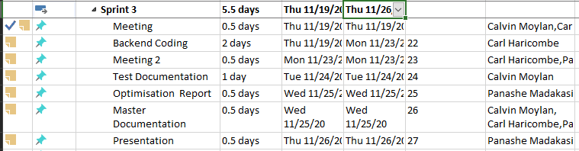

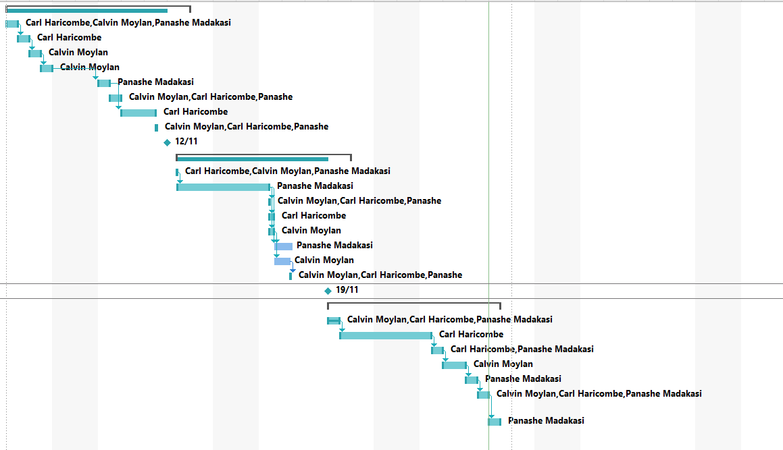

|  |
| --- |
|  |
|  |
|  |
|  |
|  |
|  |
|  |

|  |  |  |
| --- | --- | --- |
| Meetings Minutes | | |
| Call between Carl and Panashe  19/11/2020 | |  |
| Carl and Panashe  23/11/2020 | |  |
| FIN:  Panashe Madakasi  Calstar: Calvin Moylan  23/11/2020-25/11/2020 |  | |

## Source Control

A Sprint three folder has been added to the repository being used on GitHub to easily distinguish the three different sprints and their files shown below, this source control helps the group organize files and code keeping the files UpToDate.

For the third sprint the repository was managed by Panashe with Carl and Calvin uploading their completed tasks to the sprint three file created.

Link: https://github.com/CalvinMoylanTAFE/RapidAppDevelopment/blob/main/Sprint%20Two/RapidAppDevelopment-main/Master%20Document%20and%20Reports/Master%20Document.docx

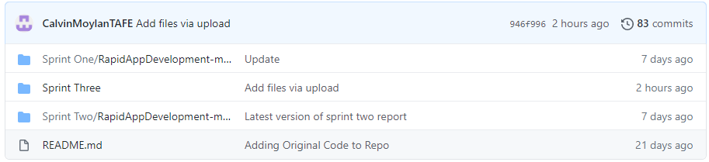

## Test plan

### Introduction

The client has asked us to implement new functionality for the third sprint of production. These new requests include a password system for website administrators and ACME personnel. The passwords must meet a minimum password complexity test. The users must also be able to rate the movies on the website. They also asked us to implement a live top 10 page for displaying the highest rated movies on the website which needs to automatically update.

### Scope

#### Features (Movie Database website) In Scope

* Add a password system for Administrators and ACME personnel
* Passwords in the system must meet a minimum complexity
* Ability for users to rate movies
* A live automatically updates top 10 ranked movies page.

#### Functional

* Admin and ACME personnel login
* Password System includes minimum complexity
* User rating movies
* Display top 10 ranked movies

#### Non- functional requirements

* The Movies Rankings Database
* Admin and ACME password Database
* Rate movies page/form

### Quality Objective

* All features have been correctly implemented as per requested by the client.
* There are no bugs or errors with the production version of the website.

### Roles and Responsibilities

Panashe Madakasi (Scrum Master)

* Project management plan (sprint one)
* Master Document Sprint 2 addition
* Source control Snapshot
* Demonstration
* Optimisation Report

Carl Haricombe

* Coding (Developer)

Calvin Moylan

* Software Development Testing Plan

### Test Methodology

#### RAD (Rapid application Development)

Moving on from sprint two, which required us to implement a newsletter subscription and an admin portal, we have been requested to implement a new Admin and ACME personnel password system. This will require a change to password database as well as include a minimum complexity for the password. We are also required to implement a rating system to the movies which are stored on the website. This will also require a slight change to the movies database which will now need to keep track of user ratings. Finally, we must also include a top 10 ranked movies page which will display a table of the top 10 ranked movies that automatically updates.

### Testing strategy

For the testing strategy, we have decided to use behavioral tests. This way we can test that all new functionality that we have recently implemented works as intended. This is also known as Blackbox testing since it will only focus on the front end working as intended as the users do not need to know what is happening behind the scenes.

### Quality Assurance

* Quality assurance will up to the CITE’s management standards evaluation project performance and the hand off complies with customer requirements.

### Testing Environment

|  |  |
| --- | --- |
| **OS** | **Browser** |
| Windows 10 | Chrome |

### Hardware requirements

* Windows 10 (Computer)
* Internet connection
* Peripherals such as a mouse and keyboard
* Monitor

### Test Cases

|  |  |  |  |
| --- | --- | --- | --- |
| Prototype | Proofing | Description | Result |
| Rating a movie |  | User can search for movie and give it a rating | Pass |
| Live Rating Chart |  | Users can view the highest rated movies through the live rating chart. | Pass |
| Admin and ACME Personnel Login |  | Admin and ACME Personnel login page that requires a password of minimum complexity | Pass |

## Optimisation Report

Optimisation within the website is the process of using tools or strategies to improve performance, interaction or security for the website to make website fast, responsive and secure.

* Error handling

- Error handling is very important, descriptions of errors can be helpful for usability to both programmers and users, users should be able to use the website without error but if they encounter an error it should be apparent that there’s a problem with a message not to waste the users time figure out why a function isn’t working or why a site is down. Messages like error 404 page not found and a under maintenance page asking the user to come back later are standards in the industry. These pages explain there is a problem and give the user a suggestion to fix the problem.

Problems users might run into and solutions given in the website include:

* Logging into the admin page
  + Admin ID: if the user tries to type with characters that aren’t numbers
  + Suggestion given: Only input Number for ID
  + Admin password: if a password is too short
  + Suggestion given: Invalid Password too short
  + Admin Email: if an invalid email is typed
  + Suggestion given: Invalid Password too short
* Signing up for the website’s membership
  + User First Name: If the user uses numbers
  + Suggestion given: Only accepts Letters
  + User Last Name: If the user uses numbers
  + Suggestion given: Only accepts Letters
  + User Email: User types invalid email
  + Suggestion given: Invalid email

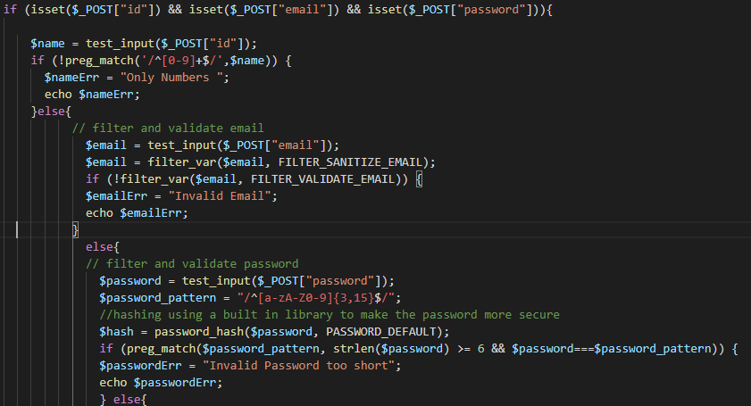

# Handover

# Carl Haricombe

30019812

## WCAG

WCAG (Web Content Accessibility Guidelines) is a web design and functionality standard that should be followed when developing a commercial website. It lists the ideal ways to create a website that is accessible for all whether it be on a mobile device or for someone who is handicapped. WCAG information can be found at <https://www.w3.org/WAI/standards-guidelines/wcag/>.

**WCAG 2.0:**We have followed these standards by:   
**1 Perceivable:**Wemade sure that content was easy to see by separating foreground from background.

**2 Operable:**We made sure that the entire website could be used from just the keyboard alone.  
Users have enough time to read and consume the content on the website.  
The website design does not cause seizures.

**3 Understandable:**   
Making sure that the colors we used for background and foreground text contrasts against each other. This makes all text we used on the website readable.  
We made the website operate in a way that was predictable and consistent throughout the entire site.

**4 Robust:**We have maximized compatibility with existing and future user agents.

These are the WCAG standards we followed in creating the website.

|  |  |
| --- | --- |
| Description | Website Pages |
| To make the website more accessible we have made all the text white on a contrasting background.  We have text larger and more readable and buttons larger and have maintained a consistent style through out the website. All the pages a user would need are at the top navigation bar. | C:\Users\student\AppData\Local\Microsoft\Windows\INetCache\Content.Word\home screen.PNG |
|  | C:\Users\student\AppData\Local\Microsoft\Windows\INetCache\Content.Word\sub page.PNG |
|  | C:\Users\student\AppData\Local\Microsoft\Windows\INetCache\Content.Word\rate page.PNG |
|  |  |

# Review Report

## How the team ensured the development quality of the software during the three sprints

We compared our updated site with the expectations and requirements of the client and the previous website. The methods we used to go about this were pretty simple, when each team member completed their end of the assignment, we would upload it to Github and notify the others to check that all the needs of the client had been for example the client wanted a multiplatform website and so we went on a venture to find the best and quickest solution which we believed to have been a responsive website.

We ensured that we followed the QA cite ISO 9001 and 90003 with regards to the code testing and processes of the website. Making use of dynamic verification method where we are able to monitor the working behavior of the software while executing the prototype. And blackbox validation method to test the front end and assure the client that the backend is working accordingly to the requirements they had given us for the 3 sprints.

## What processes were utilised to ensure adequate control of the quality of the development process.

|  |  |
| --- | --- |
| **GUI Design** | |
| Easily visible for people with Colourblind disabilities | Passed |
| Text is clear to see | Passed |
| **Functionality** | |
| Search a movie by title etc | Passed |
| Display graph of most searched movies | Passed |
| Rate a movie | Passed |
| Display graph of movie ratings | Passed |
| Create a new user | Passed |
| User can delete account | Passed |
| Admin can remove a user | Passed |
| **Security** | |
| User login through name and gmail address | Passed |
| Admin login through usercode, gmail and password | Passed |

## Describe the code testing process.

### Software Verification:

#### Dynamic verification

This focuses on the working behavior of the software and is done during the execution of the system.

### Software Validity:

#### Black Box testing

This is where the internal design of the prototype that is being tested, isn’t directly known to the tester. In other words, the team tested only the front end of the final product at the end of each sprint.

We also made use a performance report which was used to test the responsiveness and speed of the website.

We also used an Optimization report where we used code sniffer to detect any bugs or glitches in our site or where there was any syntax or logic errors.

## How can the software be supported for future modification and refinements (comments, code documentation, development plans).

### Comments:

Whoever may need to carry the website on further can just follow the comments to understand what certain algorithms were used for and how we went about it. Our comments clearly define what the purpose was shows the additional code to the new website as opposed to the previous.

### Code Documentation:

Our documentation such as our test documentation and master documentation clearly define the different areas that needed to be added such rating a movie and adding a graph as well as making the website responsive. So by using our code documentation you can take it further and add on to where the next changes may be made.

### Development plans:

After every sprint there was a development plan to display who did certain tasks in that sprint and who checked that person’s work.

## Provide a mapping of the user requirement to the final software product (did you meet the client’s expectations and requirements)

Yes, I believe the team has met the client’s requirements. In saying so we had tested one another’s work after every sprint to ensure each requirement was met no matter how small the task. We were able to do so through github when we’d upload our end and communicate with one another to find out what could be done better or what was missing.

Furthermore, we presented the final product for that sprint at the end of each sprint to ensure the client is pleased with the result before deployment.

# Source Control Snapshot

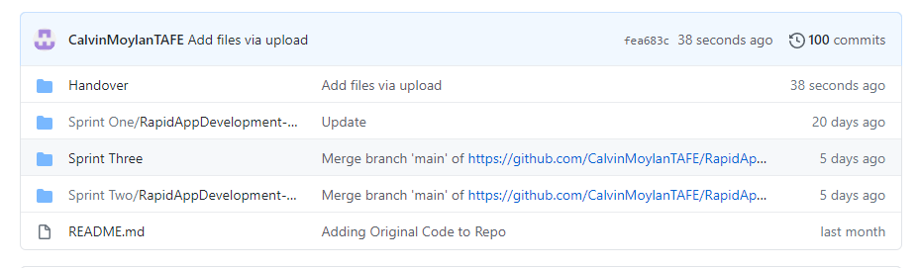

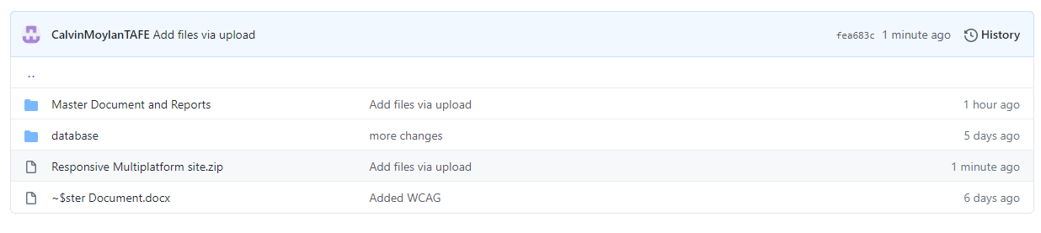

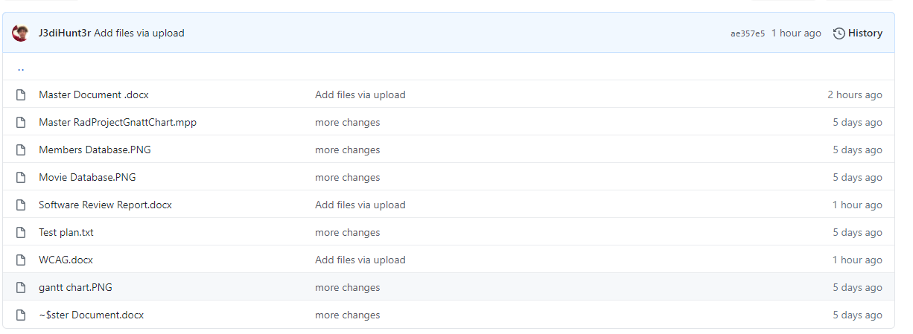

# Project Plan

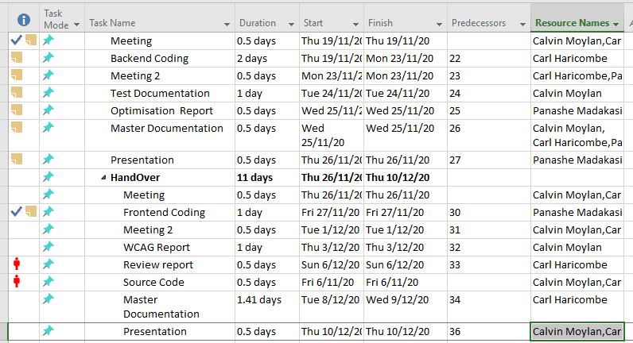

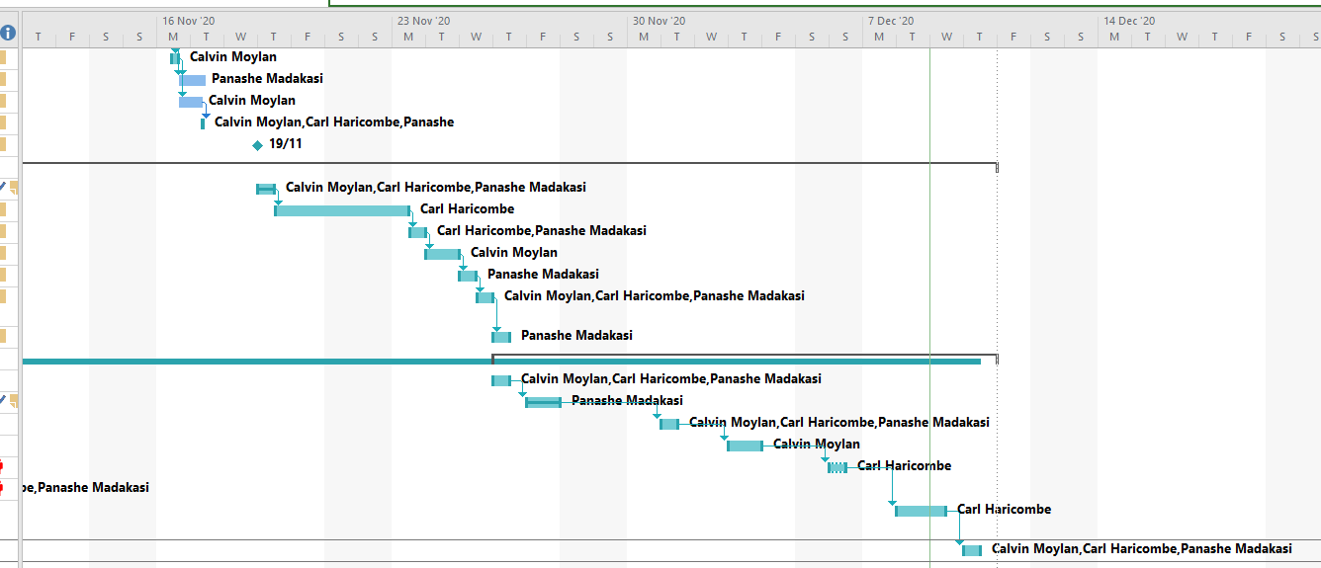

## Notes

